March 21, 2008

Dear Colleague:

On behalf of the National Science and Technology Council’s interagency Subcommittee on Disaster Reduction (SDR), we are pleased to present you with the Grand Challenges for Disaster Reduction Implementation Plans.

These hazard-specific implementation plans have been developed in support of the Grand Challenges for Disaster Reduction, a 10-year strategy produced by SDR in 2005. They represent priority Federal science and technology investment needs to help the Nation reduce future loss of life and property as a result of disasters.

Coordinated among myriad Federal agencies, the plans list actions that agencies, in collaboration with individuals and organizations at all levels, must take in order to meet the Grand Challenges for coastal inundation, drought, earthquakes, floods, heat waves, human and ecosystem health hazards, hurricanes, landslides, technological hazards, tornados, tsunamis, volcanoes, wildfires and winter storms.

Natural and technological hazards are inevitable, but their consequences on communities and infrastructure are not. In a more disaster-resilient America, relevant hazards are recognized and understood, communities at risk know when a hazard event is imminent, property losses and lives at risk in future natural hazard events are minimized, and disaster-resilient communities experience minimum disruption to life and economy after a hazard event has passed. Those are the goals of meeting the Grand Challenges.

To obtain additional information or request a briefing, please contact the SDR Secretariat, Emily Wallace at 703-560-7448 or ewallace@grs-solutions.com. For your convenience, a copy of the plans also may be found online at www.sdr.gov.

Sincerely,

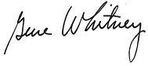
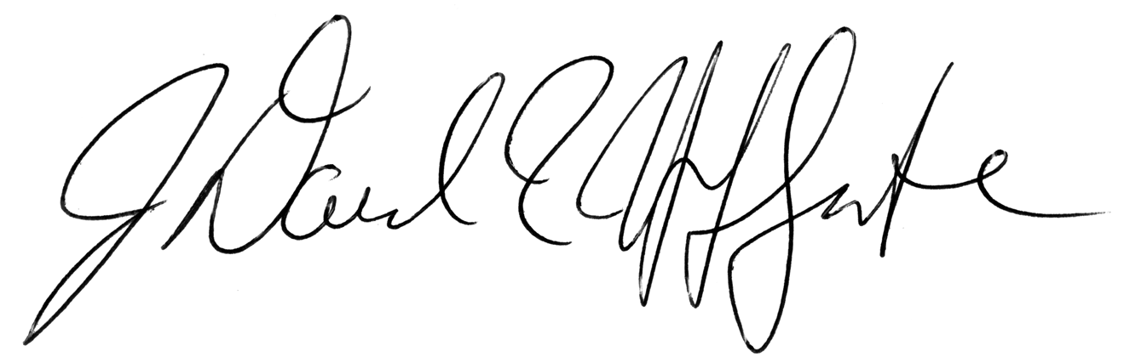
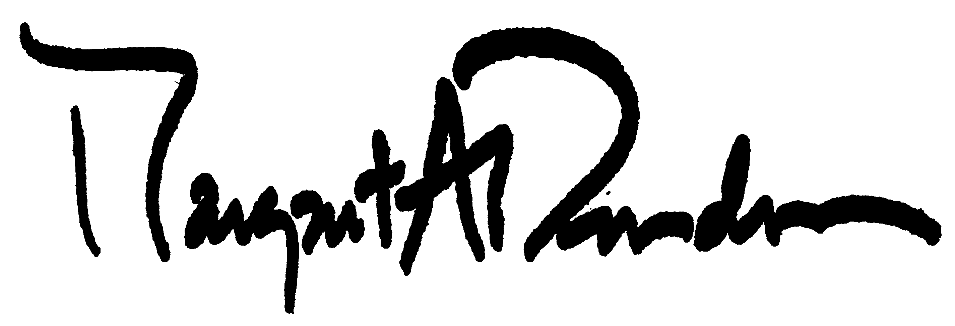

___________________ ______________________ _________________
David Applegate, USGS Margaret Davidson, NOAA Gene Whitney, OSTP
Chair, SDR Vice Chair, SDR NSTC Liaison, SDR

